Assignment 2

CST-235

Richard Boyd

July 22, 2018

The code for assignment 2 can be found at: <https://github.com/RichardvBoyd2/CST-235assignment2>

Assignment 2a was a basic web application that used a Java Servlet. It starts with a form for a user’s first and last name, and then displays a short message using both the user’s first name and last name after clicking submit.

* Pages:
  + TestForm.jsp
    - This is the first page, it contains text fields for a first and a last name, and a submit button. This page activates the managed bean TestServlet.java
  + TestResponse.jsp
    - The last page displays the short message, using information from the object created by TestServlet.java
* Classes:
  + TestServlet.java
    - 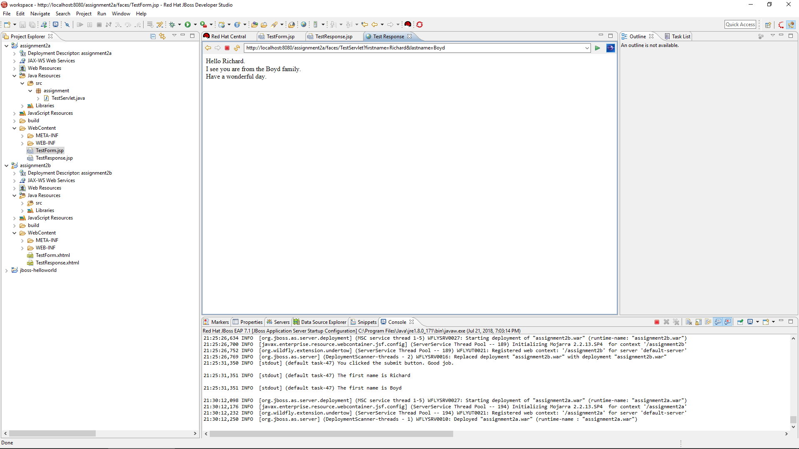Takes the information from TestForm.jsp and creates an object with the attributes firstName and lastName

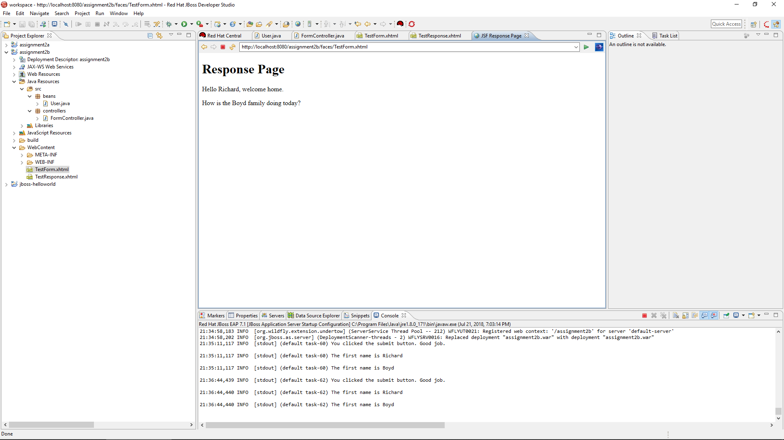Assignment 2b started similar to 2a, but used JSF and a controller bean to achieve the same goal. The controller took the data from the Form page, stores it in a user object, then activates the response page.

Assignment 2c added data validation and Facelets to our project. It added the @NotNull and @Size annotations to the input fields, stopping the application from going to the next page if the fields didn’t meet the criteria. 2c also added Facelets to create a reusable layout to our page that could be adjusted 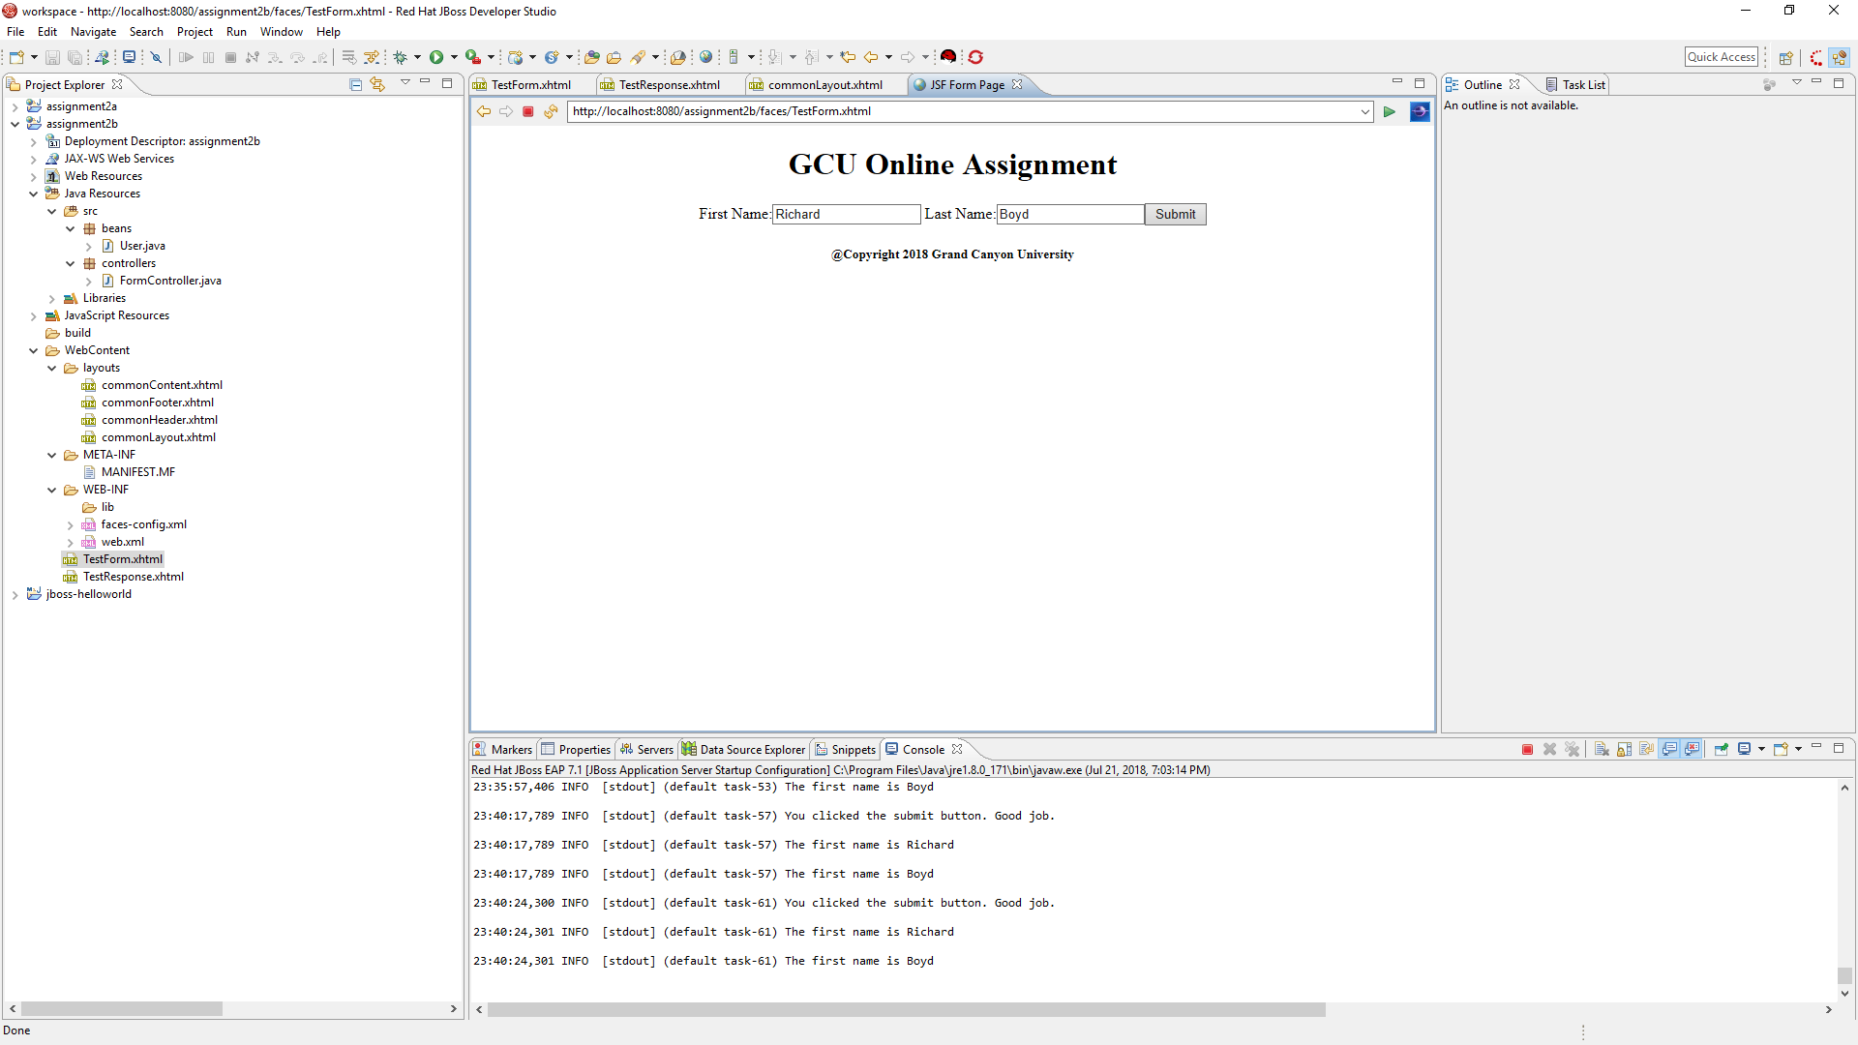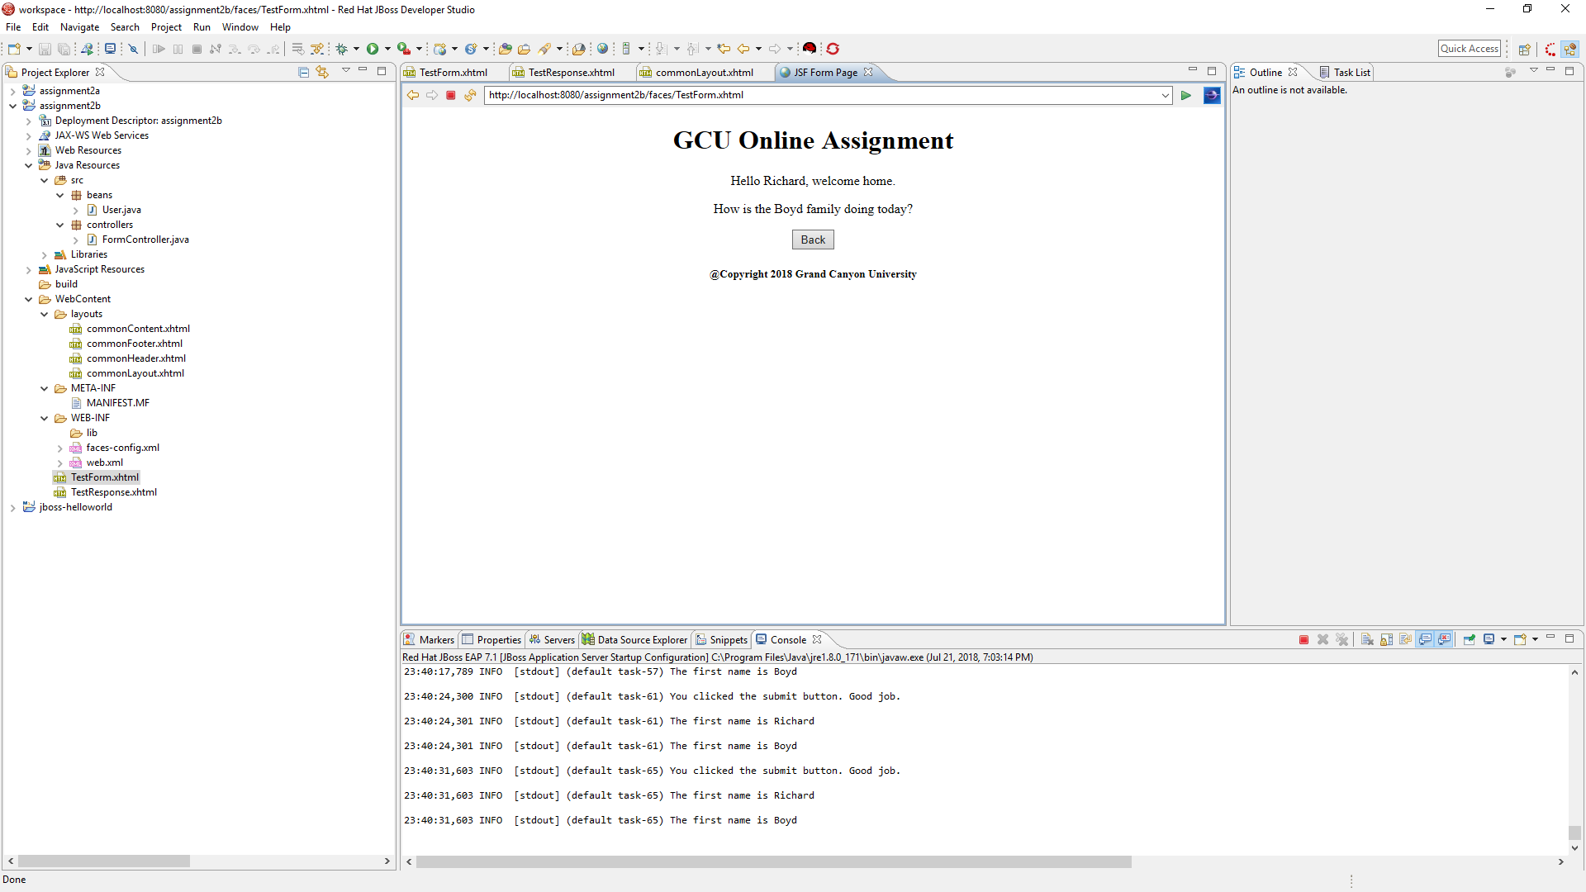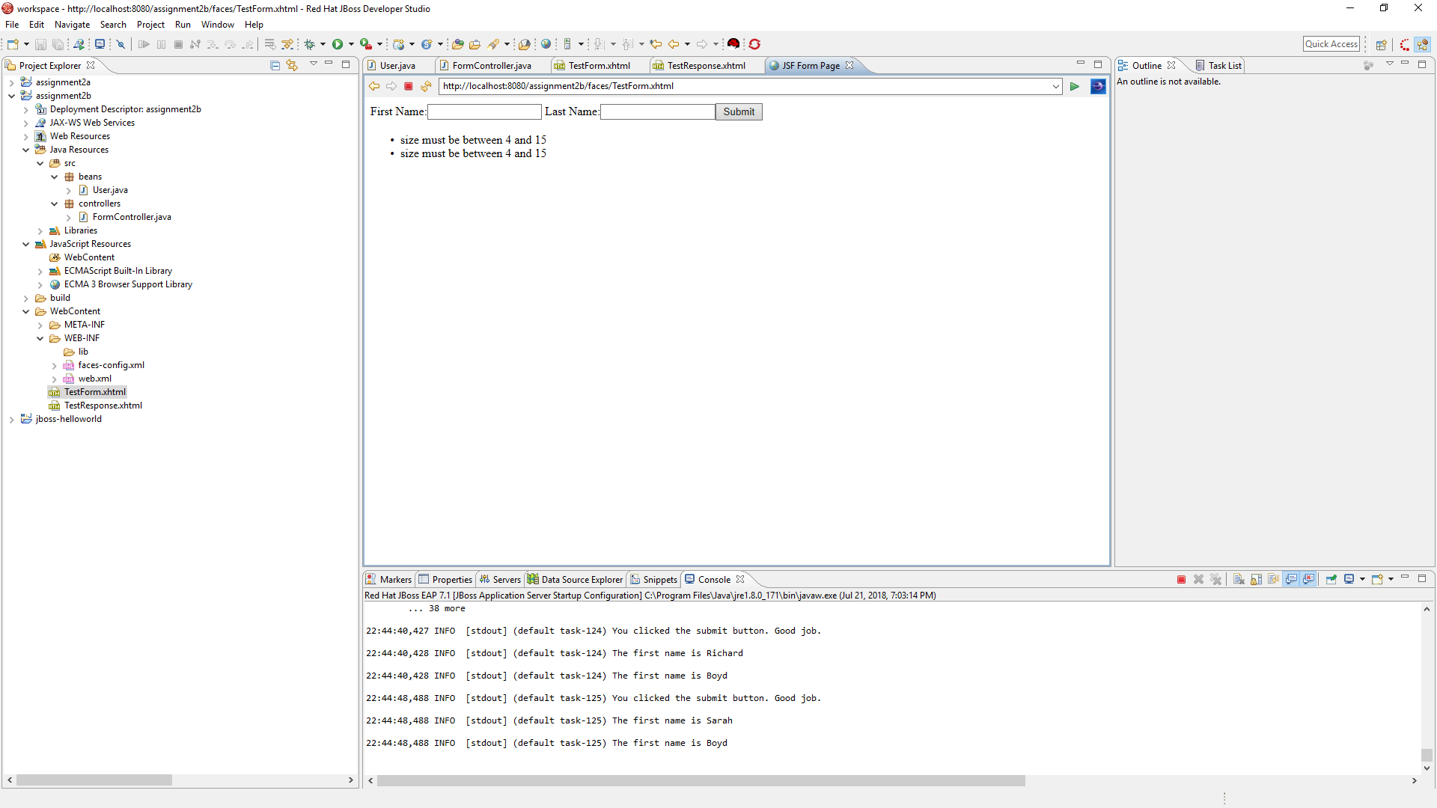in specific cases. 2c also required a back button to be added to the response page.

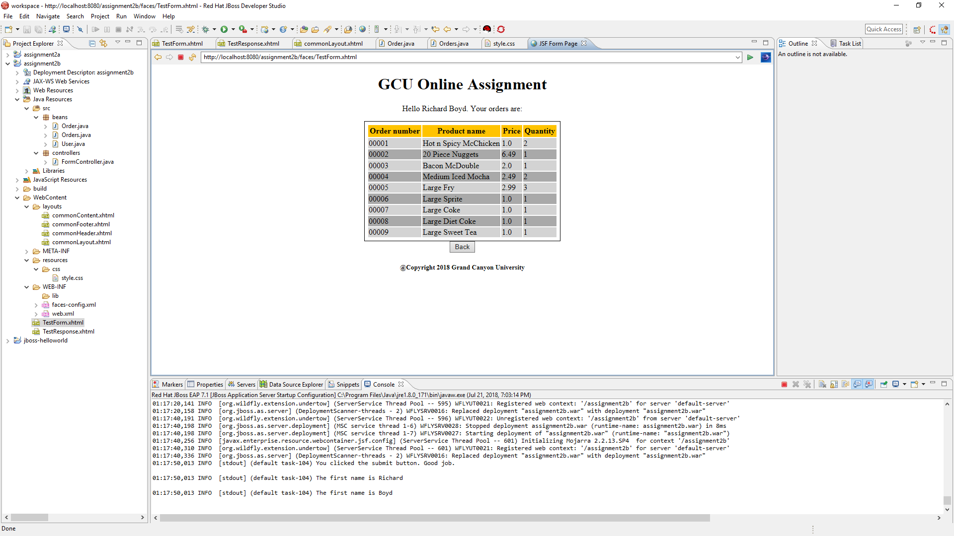In 2d I changed the response page by adding a JSF data grid. I created an Order class, and an Orders class that creates a list of Order objects. I then added a data grid to the response page that reads the objects’ attributes and displays them in a table. I also created a css stylesheet for the data grid to read off of for it’s css style.

Pages:

* TestForm.xhtml
* TestResponse.xhtml

Classes:

* FormController.java
* User.java
* Order.java
* Orders.java